***HemiSphere***

***Outcome***

***Shape***

***Cone***

***Cube***

***Prism***

***Option 4***

***Option 3***

***Option 2***

design #4

***Option 1***

***Eye***

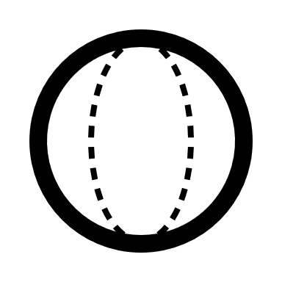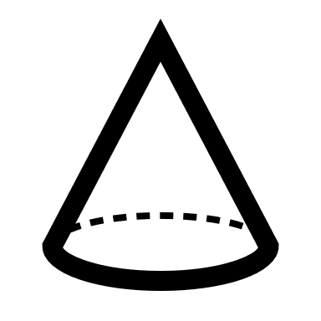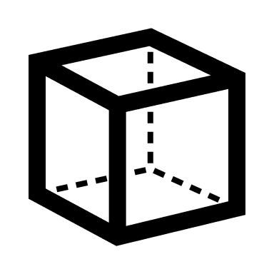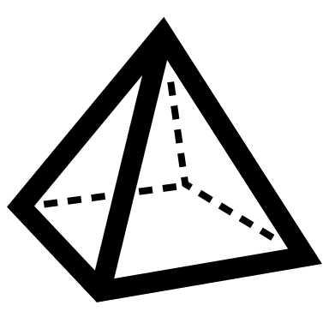

***Joint method***

**Fastening**

**Welding**

**Cliping**

***Aluminum***

***Glass***

***Plastic***

***Steel***

***Material***

Hollow-Cube shape with Nails and bolts and the material is steel or alumium